 Project Design Phase

Problem – Solution Fit Template
Date | 27 January 2026
Team ID | LTVIP2026TMIDS28465
Project Name | ShopEZ : One-Stop Shop for Online Purchases
Maximum Marks | 4 Marks
Problem – Solution Fit Template
The Problem–Solution Fit simply means that you have found a problem with your customer and that the solution you have realized for it actually solves the customer’s problem. It helps entrepreneurs, marketers, and corporate innovators identify behavioral patterns and recognize what would work and why. Purpose
- Solve complex problems in a way that fits the state of your customers
- Succeed faster and increase your solution adoption by tapping into existing mediums and channels of behavior
- Sharpen your communication and marketing strategy with the right triggers and messaging
- Increase touch-points with your company by solving frequent annoyances, or urgent or costly problems
- Understand the existing situation in order to improve it for your target group

Template:
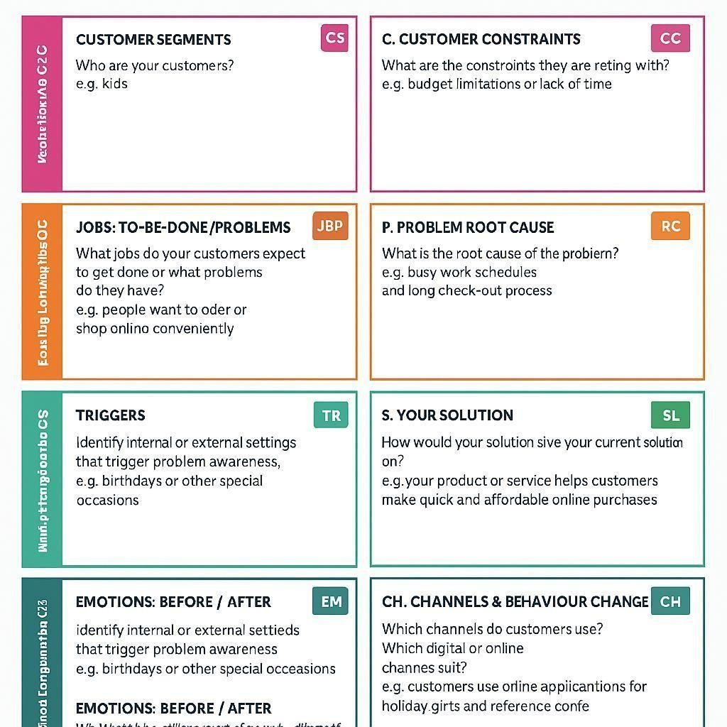
Reference: https://github.com/damesh13/shopez-one-stop-shop-for-online-purchases

